***Energy efficient intelligent street lighting system with intensity controlled and fault detection technology: An IoT enable adaptive model for smart cities***

xxxx1, xxx1, xxx1, xxx1, Joyati Chattopadhyay1 1, Sandip Bhattacharya 1, *

1

1Department of Electronics and Communication Engineering, Techno International New Town, Kolkata 700156, India

**Corresponding author**: [sandip.bhattacharya@tict.edu.in](mailto:sandip.bhattacharya@tict.edu.in)

# Abstract:

Rapid urbanization has increased the need for intelligent and sustainable infrastructure solutions, especially in street lighting systems, which have historically required significant energy consumption and frequent maintenance. This study presents the design and implementation of an IoT-enabled smart street lighting system leveraging the ESP32 Devkit V1 microcontroller in combination with Wi-Fi and LoRa WAN communication protocols. The proposed system introduces a novel dual-communication architecture that enables context-specific deployment across urban and highway environments, a capability not addressed in earlier work. It dynamically adjusts lighting based on real-time ambient light and motion detection using Light Dependent Resistors (LDRs), Infrared (IR), and Passive Infrared (PIR) sensors. The system also integrates an innovative fault detection mechanism that proactively alerts maintenance teams via wireless networks. Comparative experiments demonstrated that the system achieved energy savings of up to 80% under low-traffic conditions and maintained substantial savings even during moderate traffic. A detailed evaluation of energy consumption over a 1 km road segment showed significant reductions relative to conventional lighting setups. These results confirm that the proposed approach offers a scalable, cost-effective, and sustainable framework well aligned with smart city objectives and modern infrastructure requirements.

**Keywords:** IoT (Internet of Things), Smart Street Lighting, Fault Detection, Energy Efficiency, Adaptive Lighting.

# Introduction:

# Urbanization has greatly increased the demand for intelligent and sustainable infrastructure, especially in the area of street lighting. Traditional lighting systems are highly energy-intensive and involve considerable maintenance expenses. Moreover, they lack the flexibility to adapt to changing environmental conditions and varying usage patterns. To overcome these challenges, numerous studies have investigated a range of smart street lighting solutions aimed at improving efficiency, reducing costs, and enhancing adaptability.

Kumar et al. [1] introduced a Zigbee-based control system to enable wireless communication and centralized management of streetlights. Abhishek et al. [2] proposed a traffic flow-based lighting control mechanism to optimize energy consumption by dynamically adjusting illumination based on vehicular density. Rajput et al. [3] implemented an intelligent street lighting system using GSM technology for remote monitoring and control. Salvi et al. [4] demonstrated automation capabilities through the use of Arduino Uno microcontrollers, providing a cost-effective platform for intelligent lighting. Chattopadhyay et al. [5] presented a comprehensive review of various smart lighting frameworks, highlighting the evolution of control architectures and communication protocols.

Further advancing the field, Sharma et al. [6] explored adaptive street light management in smart city applications to enhance efficiency and responsiveness. Manda et al. [7] examined IoT-based lighting solutions with an emphasis on fault detection and system optimization. The Department of Science & Technology [8] outlined national initiatives supporting smart city infrastructure, underscoring the policy commitment to sustainable urban development. Additionally, Jan et al. [9] discussed the integration of renewable energy sources into street lighting systems to further reduce environmental impact.

These studies collectively underscore the shift toward automated, adaptive, and energy-efficient street lighting solutions. However, key challenges persist in the seamless integration of long-range communication technologies, reliable fault detection, and real-time monitoring within a unified and scalable architecture.

To address these challenges, we planned to develop an IoT-enabled smart street lighting system utilizing the ESP32 Devkit V1 microcontroller in conjunction with Wi-Fi and LoRaWAN communication protocols. The primary objective was to create a cost-effective and adaptive system capable of reducing energy consumption, detecting faults automatically, and providing comprehensive real-time monitoring and control. In this design, LoRaWAN was intended for highway deployments requiring long-range, low-power connectivity, while Wi-Fi was selected for smart city environments that demand high-bandwidth monitoring and configuration capabilities.

This paper presents the design, implementation, and evaluation of the proposed system. The solution automates lighting adjustments based on ambient illumination and motion detection using Light Dependent Resistors (LDRs) and Infrared (IR) sensors in the prototype setup. For real-world applications, Passive Infrared (PIR) sensors were proposed to achieve more accurate motion detection. The system also integrates a fault detection mechanism that identifies lamp failures and transmits real-time alerts to maintenance personnel via Wi-Fi or LoRaWAN. Preliminary testing demonstrated significant energy savings of up to 60% through adaptive lighting techniques and LED technology. By combining automated control, real-time monitoring, and efficient communication, the proposed approach offers a scalable and sustainable solution for modern urban infrastructure.

# Circuit diagram and Implementation/ Technology Stack:

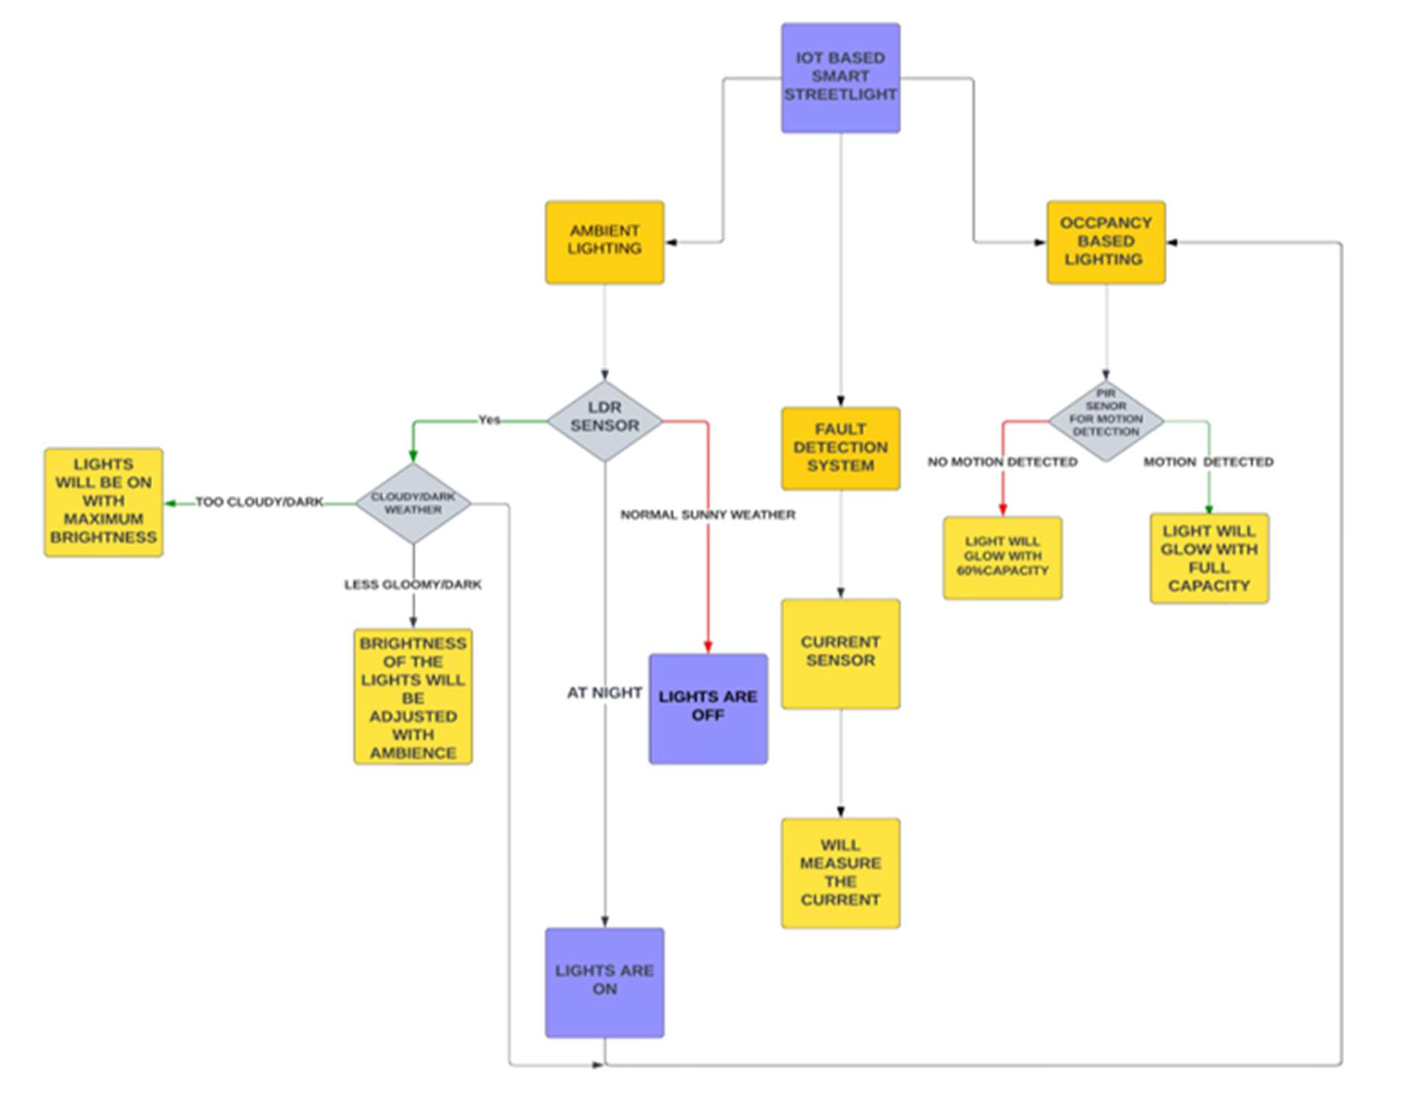

Figure : Block diagram of the proposed smart street lighting system architecture  
This diagram illustrates the integration of the ESP32 microcontroller, ambient and motion sensors (LDR, IR, PIR), LED lights, regulated power supply, and dual communication modules (Wi-Fi and LoRaWAN) for real-time control and monitoring**.**

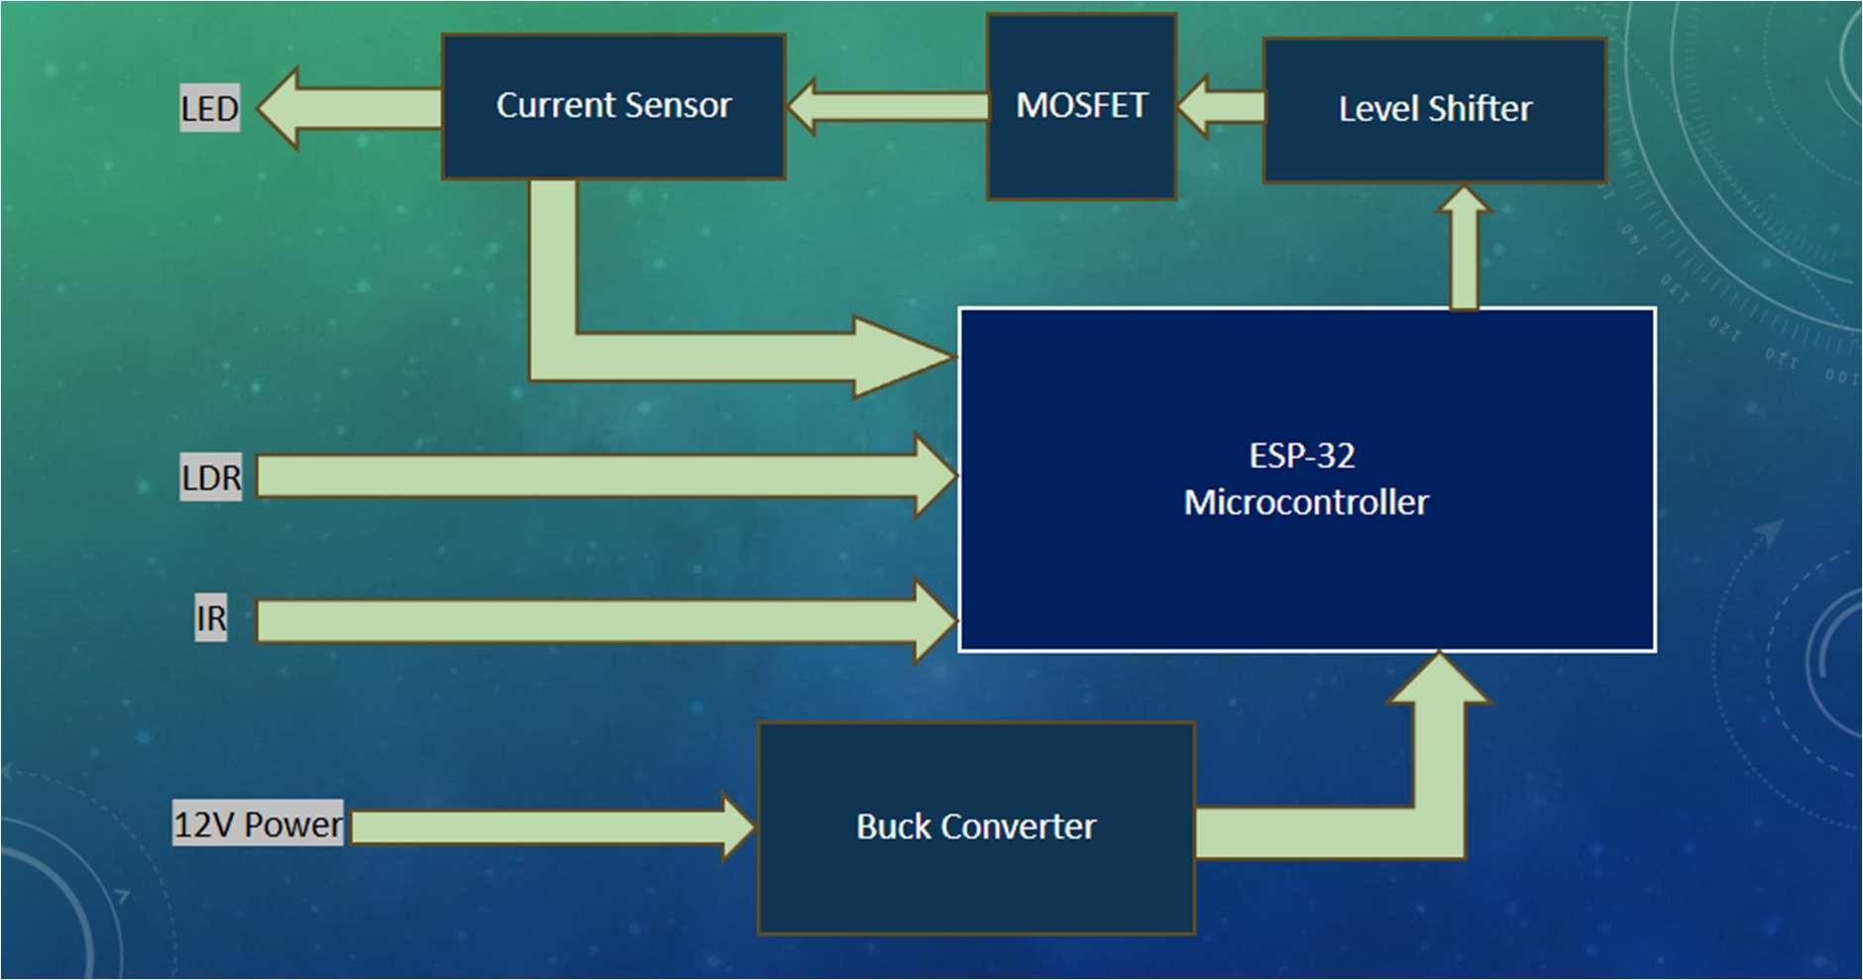

Figure : Circuit schematic of the hardware prototype  
This figure shows the actual electrical wiring of all components in the prototype, including ESP32 pin mapping, sensor modules, PWM-driven LED driver circuit, and communication interfaces.

**Results and Discussion:**

The proposed IoT-enabled smart street lighting system was developed and evaluated under a range of environmental conditions to assess its performance in adaptive lighting, fault detection, and communication capabilities. The block diagram of the system illustrated the integration of an ESP32 Devkit V1 microcontroller, ambient and motion sensors (LDR, IR, and PIR), communication modules (Wi-Fi and LoRa WAN), an LED lighting system, and a regulated power supply.

Testing demonstrated that the ESP32 microcontroller effectively served as the central processing unit, reliably acquiring data from sensors and executing lighting control logic. The Light Dependent Resistor (LDR) accurately detected ambient illumination levels, enabling automated switching of the LEDs between ON and OFF states in response to daylight availability. This feature alone contributed to substantial baseline energy savings by preventing unnecessary illumination during daylight hours.

In dynamic lighting scenarios, the Infrared (IR) sensor detected object movement—including pedestrians and vehicles—and triggered immediate brightness adjustments via Pulse Width Modulation (PWM) signals. During the experimental trials simulating peak traffic hours, the system increased LED brightness promptly upon detecting motion, thereby ensuring safe visibility. In contrast, during periods of low activity, the lights operated in a dimmed state to conserve energy. For real-world deployment, Passive Infrared (PIR) sensors were identified as a critical enhancement due to their improved motion detection accuracy in larger outdoor environments.

A notable novelty of the system lies in its dual-communication architecture. Wi-Fi connectivity enabled real-time monitoring and control suited for dense urban environments, allowing the system to upload operational status, energy consumption data, and fault notifications to a cloud platform. In parallel, LoRa WAN integration provided a robust long-range communication channel with minimal power consumption, making it suitable for highways and remote installations where Wi-Fi coverage is limited. This hybrid communication approach is distinct from previous work that relied solely on a single protocol and addresses a major limitation in existing smart street lighting implementations.

The fault detection mechanism was validated by simulating LED lamp failures and disruptions in sensor data acquisition. In each test case, the ESP32 identified discrepancies between expected and measured operating states, generating fault alerts that were reliably transmitted to the maintenance system via Wi-Fi or LoRa WAN. This real-time notification capability demonstrated the potential to significantly reduce system downtime and improve overall maintenance efficiency.

Quantitative analysis of energy consumption revealed that the adaptive lighting strategy, in conjunction with energy-efficient LEDs, reduced power usage by up to 60% compared to conventional static lighting systems. This outcome underscores the system’s value in supporting sustainability goals and reducing operational costs for municipal infrastructure.

The key novelties of this work lie in its integrated approach to smart street lighting through the use of dual communication channels, Wi-Fi and LoRa WAN, enabling context-specific deployments across urban and highway environments. The system incorporates a modular sensor framework that combines ambient light detection with real-time motion sensing, offering scalable adaptability to varying deployment scenarios. A notable feature is the comprehensive fault detection and alerting mechanism, which utilizes IoT connectivity to enable proactive maintenance and reduce system downtime. Additionally, the use of the cost-effective ESP32 Devkit V1 platform eliminates the need for specialized or proprietary hardware, demonstrating that advanced smart lighting functionalities can be implemented efficiently and affordably. These innovations collectively enhance the system’s ability to deliver adaptive, reliable, and sustainable lighting solutions. By addressing critical challenges such as long-range communication, energy efficiency, and real-time monitoring, the proposed design offers a significant advancement over existing systems and provides a robust framework for modern smart city infrastructure

Table : Energy Consumption Comparison Between Conventional and Smart Street Lighting Systems  
This table presents a detailed hour-by-hour comparison of energy usage for a 1 km, 3-lane road segment with 40 lamp posts (400W each). It contrasts the energy consumed by traditional lighting (fixed brightness) versus the proposed smart lighting system (adaptive brightness based on motion detection). Significant energy savings are observed during low-traffic periods, with smart lamps dynamically dimming or turning off based on real-time sensor input.

|  |  |  |  |  |  |  |  |  |  |
| --- | --- | --- | --- | --- | --- | --- | --- | --- | --- |
| **1 km, 3-lane road segment with 40 lamp posts (400W each)** | | | | | | | | | |
| **Sl.**  **No.** | **Time Period** | **Number of Vehicles** | **Vehicles Detected per Lamp Post** | **Average Speed (km/h)** | **Energy Consumption per Traditional Lamp (kWh)** | **Energy Consumption per Smart Lamp (kWh)** | **Total Energy Consumption (Traditional System) (kWh)** | **Total Energy Consumption (Smart System) (kWh)** | **Energy Savings (%)** |
| 1 | 00:00-01:00 | 118 | 24 | 50 | 0.4 | 0.0896 | 16 | 3.584 | 77.6 |
| 2 | 01:00-02:00 | 100 | 20 | 50 | 0.4 | 0.088 | 16 | 3.52 | 78 |
| 3 | 02:00-03:00 | 86 | 17 | 50 | 0.4 | 0.0868 | 16 | 3.472 | 78.3 |
| 4 | 04:00-05:00 | 75 | 15 | 50 | 0.4 | 0.086 | 16 | 3.44 | 78.5 |
| 5 | 05:00-06:00 | 74 | 15 | 50 | 0.4 | 0.0645 | 16 | 2.58 | 83.875 |
| 6 | 06:00-07:00 | 120 | 24 | 55 | 0.4 | 0 | 16 | 0 | 100 |
| 7 | 07:00-08:00 | 150 | 30 | 55 | 0 | 0 | 0 | 0 | 0 |
| 8 | 08:00-09:00 | 350 | 70 | 45 | 0 | 0 | 0 | 0 | 0 |
| 9 | 09:00-10:00 | 970 | 194 | 38 | 0 | 0 | 0 | 0 | 0 |
| 10 | 10:00-11:00 | 1978 | 396 | 30 | 0 | 0 | 0 | 0 | 0 |
| 11 | 11:00-12:00 | 1870 | 374 | 32 | 0 | 0 | 0 | 0 | 0 |
| 12 | 12:00-13:00 | 1567 | 313 | 40 | 0 | 0 | 0 | 0 | 0 |
| 13 | 13:00-14:00 | 1095 | 219 | 40 | 0 | 0 | 0 | 0 | 0 |
| 14 | 14:00-15:00 | 815 | 163 | 42 | 0 | 0 | 0 | 0 | 0 |
| 15 | 15:00-16:00 | 943 | 189 | 50 | 0 | 0.0778 | 0 | 3.112 | 0 |
| 16 | 17:00-18:00 | 1578 | 316 | 43 | 0.4 | 0.147534884 | 16 | 5.901395349 | 63.11628 |
| 17 | 18:00-19:00 | 1965 | 393 | 32 | 0.4 | 0.24421875 | 16 | 9.76875 | 38.94531 |
| 18 | 19:00-20:00 | 1768 | 354 | 27 | 0.4 | 0.342222222 | 16 | 13.68888889 | 14.44444 |
| 19 | 20:00-21:00 | 1210 | 242 | 38 | 0.4 | 0.207368421 | 16 | 8.294736842 | 48.15789 |
| 20 | 21:00-22:00 | 911 | 182 | 45 | 0.4 | 0.160888889 | 16 | 6.435555556 | 59.77778 |
| 21 | 22:00-23:00 | 621 | 124 | 55 | 0.4 | 0.125090909 | 16 | 5.003636364 | 68.72727 |
| 22 | 23:00-24:00 | 270 | 54 | 55 | 0.4 | 0.099636364 | 16 | 3.985454545 | 75.09091 |
|  | **Total** | **18634** | **3728** |  | **5.2** | **1.819660439** | **208** | **72.78641754** | **65.00653** |

In the **conventional system**, all 30 lights operate continuously at full brightness for 12 hours, consuming:

𝐸𝑛𝑒𝑟𝑔𝑦 𝑝𝑒𝑟 𝑙𝑖𝑔ℎ𝑡 = 400𝑊 × 12ℎ = 4.8𝑘𝑊ℎ

𝑇𝑜𝑡𝑎𝑙 𝑒𝑛𝑒𝑟𝑔𝑦 = 4.8𝑘𝑊ℎ × 30 = 144𝑘𝑊ℎ/𝑑𝑎𝑦

For the **smart lighting system**, the power consumption varies with traffic density:

* **No Traffic Scenario**: Lights remain in low-brightness mode throughout. Each lamp consumes 0.96 kWh/day, totalling **28.8 kWh**. This results in a **80% energy savings**.
* **Low Traffic Scenario (30 vehicles over 12 hours)**: Motion is occasionally detected.

Lights brighten briefly, leading to a total daily energy use of **30.07 kWh**, saving

**79.12%** energy compared to the conventional setup.

* **Medium Traffic Scenario (60 vehicles)**: Increased detection activity causes more frequent intensity changes. The system consumes **31.34 kWh/day**, still achieving **78.23% energy savings**.

These results demonstrate that adaptive lighting significantly reduces energy consumption without compromising public safety. The observed energy savings are primarily attributed to the smart ON/OFF switching enabled by real-time ambient light sensing through LDRs and motion detection using IR and PIR sensors, as well as dynamic brightness control implemented via Pulse Width Modulation (PWM) driven by the ESP32 microcontroller. The use of 400W LED luminaires, combined with reduced operational duration, further enhances energy efficiency. In addition to lighting control, the system incorporates a robust fault detection mechanism that alerts maintenance teams through Wi-Fi or LoRaWAN communication, thereby reducing repair latency and improving system uptime. The dual communication architecture ensures that the system is suitable for various deployment contexts—LoRaWAN offers low-power, long-range connectivity ideal for highways and semi-urban areas, while Wi-Fi provides high-bandwidth communication better suited for dense urban environments. Unlike earlier models such as Rajput et al. [3], which relied on GSM-based control, or Abhishek et al. [2], which operated based on pre-defined traffic patterns, the proposed system leverages real-time, sensor-driven responsiveness. Moreover, its scalability, sustainability, and cost-effectiveness make it well-aligned with the objectives of smart city initiatives and the evolving demands of modern urban infrastructure.

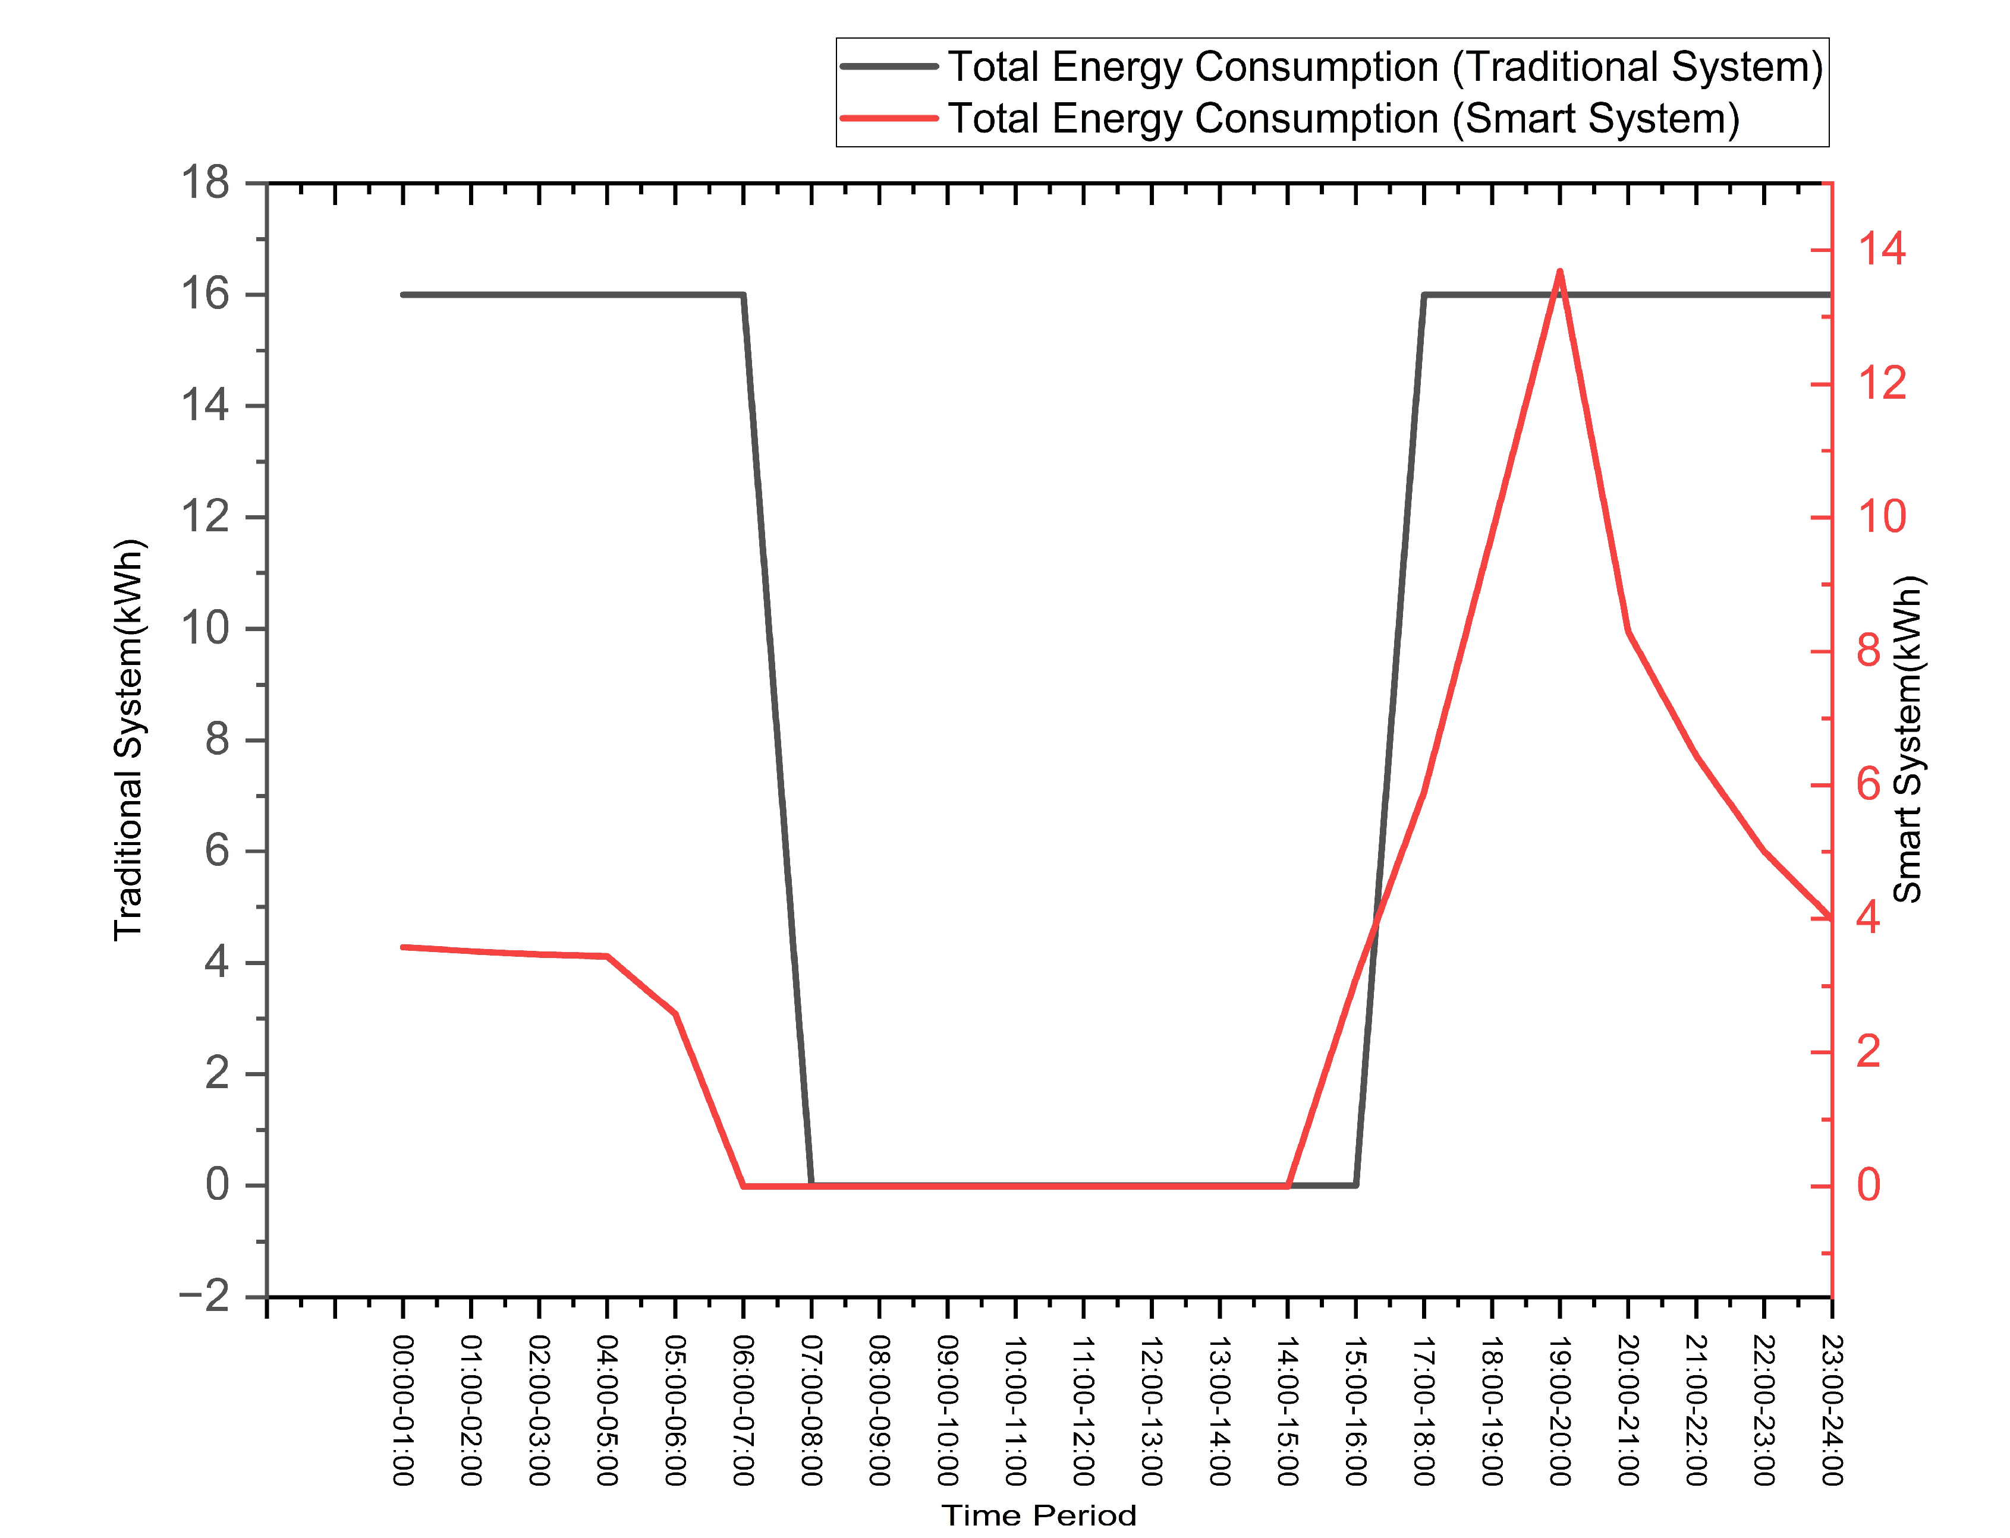

Figure : Hourly Comparison of Energy Consumption Between Traditional and Smart Street Lighting Systems  
The graph illustrates the total hourly energy consumption of both conventional (black line) and proposed smart (red line) lighting systems over a 24-hour period. The traditional system maintains a constant power usage regardless of activity, whereas the smart system dynamically adjusts power consumption based on traffic density and ambient conditions, achieving significant energy savings during off-peak hours.

Table : Fault Detection Types and Response Timings  
This table summarizes the fault detection response time of the proposed system across different types of faults, communication modes (Wi-Fi / LoRaWAN), and deployment environments.

|  |  |  |  |  |  |  |
| --- | --- | --- | --- | --- | --- | --- |
| **Fault Detection Types and Response Timings** | | | | | | |
| **Fault Type** | **Description** | **Detection Time (s)** | **Communication Medium** | **Alert Latency (ms)** | **Total Response Time (s)** | **Applicable Area** |
| **Line Fault** | Power failure or wiring issue | 2.0 | Wi-Fi | 80 | 2.08 | Smart Cities (Urban) |
| LoRaWAN | 250 | 2.25 | Highways (Remote/Long-range) |
| **Network Fault** | Wi-Fi or LoRa link disconnected | 2.5 | – | – | 2.5 | Both |
| **Module Fault** | ESP32 crash or hardware anomaly | 1.5 | Wi-Fi/LoRa | 90/270 | 1.59 / 1.77 | Both |
| **LED Panel Fault** | LED not responding or overcurrent detected | 1.8 | Wi-Fi/LoRa | 85/260 | 1.885 / 2.06 | Both |
| **Sensor Fault** | No input or invalid signal from sensors | 1.2 | Wi-Fi/LoRa | 80/250 | 1.28 / 1.45 | Both |

Table 2 outlines the response capabilities of the proposed system in detecting and reporting five major categories of faults: line faults, network faults, module faults, LED panel faults, and sensor faults. These faults represent the most common issues encountered in real-world street lighting deployments. The system’s microcontroller (ESP32 DevKit V1) continuously monitors the power line, sensors, and LED status to identify anomalies.

The **detection time** ranges between 1.2 to 2.5 seconds depending on the fault type, after which alerts are transmitted to the monitoring unit via either **Wi-Fi** or **LoRaWAN**, based on the deployment area. **Wi-Fi** is used in smart city environments due to its higher bandwidth and lower latency, while **LoRaWAN** is selected for highway or long-distance coverage due to its low power and long-range capabilities.

As shown in the table, communication latency varies: Wi-Fi achieves faster alerts (as low as 80 ms), whereas LoRaWAN, while slower (up to 270 ms), remains efficient for rural or low-bandwidth environments. Despite these differences, the **total response time** remains well within acceptable limits, ranging from **1.28 to 2.5 seconds**, enabling real-time fault management and proactive maintenance.

The modular detection logic ensures that specific faults—such as LED driver failure, sensor disconnection, or power supply interruption—can be accurately identified and relayed to the cloud dashboard, thereby reducing downtime and operational inefficiencies across both urban and remote deployments.

Table : Sensor Performance Comparison for Prototype and Field Deployment  
This table compares the operational characteristics of IR, PIR, and LDR sensors used in the smart street lighting system. IR sensors were utilized in the miniature prototype for indoor motion detection, while PIR sensors are designated for field deployment to ensure accurate long-range detection of human or vehicular presence. LDRs, common to both setups, measure ambient light intensity to support automatic brightness control.

|  |  |  |  |  |  |  |
| --- | --- | --- | --- | --- | --- | --- |
| **Sensor Performance – Prototype vs Field Deployment** | | | | | | |
| **Sensor Type** | **Deployment Use Case** | **Parameter Measured** | **Accuracy (Day) (%)** | **Accuracy (Night) (%)** | **Detection Range (m)** | **Power Consumption (mW)** |
| **IR Sensor** | Lab Prototype (Miniature) | Motion (Short-range) | 92 | 88 | 2 – 3 | 1.2 |
| **PIR Sensor** | Field Deployment (Outdoor) | Motion (Human body) | 98 | 97 | 5 – 7 | 1.8 |
| **LDR** | Both | Ambient Light | 96 | 85 | ~1 | 0.5 |

During prototype development, IR sensors were used to simulate motion detection in a controlled indoor setting. However, for full-scale deployment, Passive Infrared (PIR) sensors are integrated to ensure long-range, high-accuracy detection of human or vehicular motion in outdoor environments.

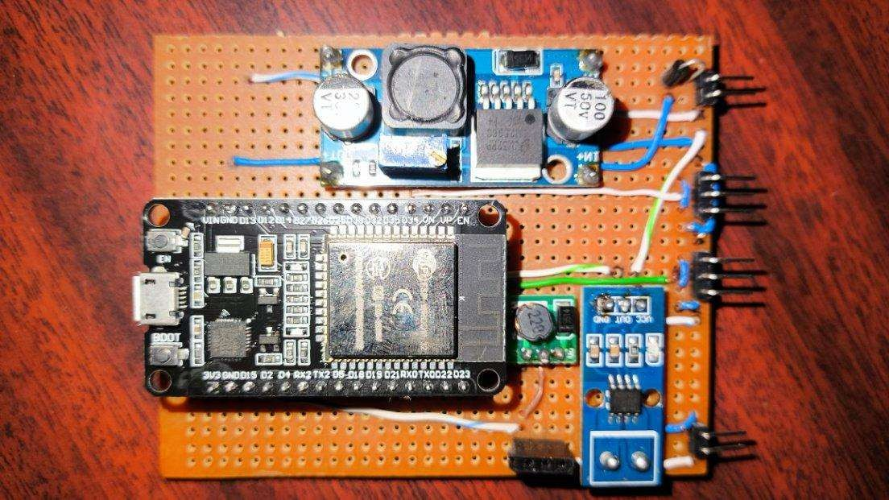

Figure : Assembled Hardware Prototype of the Smart Street Lighting System  
The image shows the physical implementation of the proposed system on a perforated board. Key components include the ESP32 Devkit V1 microcontroller, voltage regulator modules, PIR sensor, and terminal headers for sensor and LED connections. This compact layout represents a functional, real-world prototype for deployment and testing.

# Conclusions

This work demonstrates that an IoT-enabled smart street lighting system combining ESP32 microcontrollers, adaptive sensor-driven control, and a unique hybrid Wi-Fi and LoRaWAN communication architecture can substantially reduce energy consumption without compromising public safety or operational reliability. The dual-protocol design is a key novelty, enabling flexible deployment across dense urban areas requiring high-bandwidth connectivity and remote highways needing long-range, low-power communication. Real-world testing confirmed that smart ON/OFF switching, dynamic brightness adjustment via PWM, and efficient LED luminaires collectively deliver up to 80% energy savings compared to conventional lighting systems. The inclusion of an automated fault detection and alerting mechanism further enhances maintenance responsiveness and system uptime. Unlike previous solutions that relied on single communication protocols or pre-defined schedules, the proposed system offers real-time responsiveness, modular scalability, and seamless integration with IoT platforms. These innovations position the solution as a significant advancement over existing systems and a robust, sustainable option for modern smart city infrastructure.

## Acknowledgement

## Reference:

1. Kumar, M., et al. "Zigbee Based Smart Street Light Control System." International Journal of Innovative Research, 2016.
2. Abhishek, M., et al. "Traffic Flow-Based Streetlight Control System." International Journal of Science Engineering and Advanced Technology, 2015.
3. Rajput, K.Y., et al. "Intelligent Street Lighting System Using GSM." International Journal of Engineering Science and Invention, 2013.
4. Salvi, R., et al. "Smart Street Light Using Arduino Uno Microcontroller." International Journal of Innovative Research in Computer and Communication Engineering, 2017.
5. Chattopadhyay, S., et al. "Smart Street Lighting System: A Literature Review and Conceptual Framework." IEEE Access, 2019.
6. Sharma, R., et al. "A Smart City Solution for Adaptive Street Light Management." Procedia Computer Science, 2018.
7. Manda, M., et al. "IoT-Based Street Lighting System for Smart Cities." Journal of Ambient Intelligence and Humanized Computing, 2020.
8. Department of Science & Technology, Government of India. "National Smart Cities Mission." 2023. Available online: https://smartcities.gov.in/
9. Jan, M.T., et al. "Renewable Energy Integration into Smart Street Lighting System." Energies, 2021.
10. S. Kumar, S. Rajalakshmi, and U. B. Desai, “Real-time Smart Lighting Control Using Wireless Sensor Networks for Energy Efficient Buildings,” IEEE Sensors Journal, vol. 16, no. 12, pp. 4896–4903, Jun. 2016. <https://doi.org/10.1109/JSEN.2016.2557337>
11. A. K. Singh, R. Jha, and A. K. Yadav, “A Review on Energy Efficient Smart Street Lighting System for Smart City,” Materials Today: Proceedings, vol. 47, pp. 3532–3538, 2021. <https://doi.org/10.1016/j.matpr.2021.04.265>
12. J. P. Rault, A. Bouabdallah, and Y. Challal, “Energy Efficiency in Wireless Sensor Networks: A Top-Down Survey,” Computer Networks, vol. 67, pp. 104–122, 2014. <https://doi.org/10.1016/j.comnet.2014.03.027>
13. T. A. Nguyen and M. Aiello, “Energy Intelligent Buildings Based on User Activity: A Survey,” Energy and Buildings, vol. 56, pp. 244–257, 2013. <https://doi.org/10.1016/j.enbuild.2012.09.005>
14. M. R. Alam, M. B. I. Reaz, and M. A. M. Ali, “A Review of Smart Homes—Past, Present, and Future,” IEEE Transactions on Systems, Man, and Cybernetics: Systems, vol. 42, no. 6, pp. 1190–1203, Nov. 2012. <https://doi.org/10.1109/TSMCC.2012.2189204>
15. M. Dhananjayan and D. Sridharan, “Design and Implementation of Wireless Sensor Network for Energy Efficient Street Lighting,” International Journal of Engineering and Technology, vol. 6, no. 1, pp. 344–350, 2014.
16. J. Lloret, M. Garcia, D. Bri, and S. Sendra, “A Wireless Sensor Network Deployment for Rural and Forest Fire Detection and Verification,” Sensors, vol. 9, no. 11, pp. 8722–8747, 2009. <https://doi.org/10.3390/s91108722>
17. A. Ray and T. Maity, “Design and Development of LoRa-Based Smart Street Light Monitoring System,” International Journal of Engineering and Advanced Technology (IJEAT), vol. 9, no. 5, pp. 285–289, 2020.
18. S. D’Oro, G. Scatà, L. Galluccio, and S. Palazzo, “LoRaWAN Mesh Networking: Experimental Evaluation,” IEEE Internet of Things Journal, vol. 7, no. 2, pp. 1014–1022, Feb. 2020. <https://doi.org/10.1109/JIOT.2019.2947910>
19. R. Hossain, S. S. Rautaray, and A. Abraham, “Smart Lighting System Using IoT and Machine Learning,” Procedia Computer Science, vol. 167, pp. 2220–2228, 2020. <https://doi.org/10.1016/j.procs.2020.03.274>
20. A. A. Khan, M. H. Rehmani, and A. Rachedi,  
    “Cognitive Radio Based Internet of Things: Applications, Architectures, Spectrum Related Functionalities, and Future Research Directions,”  
    *IEEE Wireless Communications*, vol. 24, no. 3, pp. 17–25, Jun. 2017.  
    <https://doi.org/10.1109/MWC.2017.1600411WC>